**SQL Queries with Output Screenshots**

1. ***Retrieve the book title, category, and rental price of all available books.***

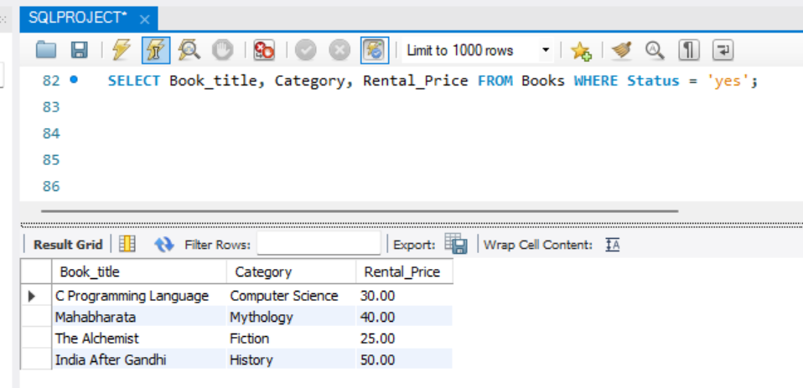

1. ***List the employee names and their respective salaries in descending order of salary.***

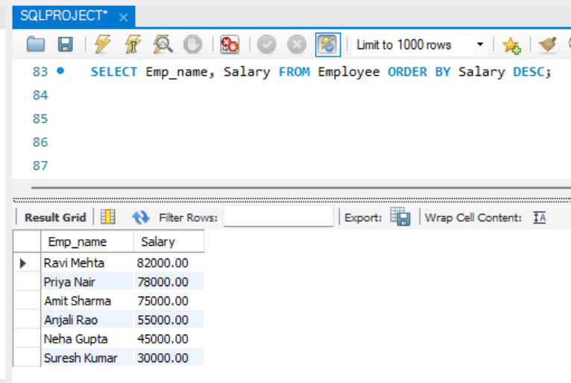

1. ***Retrieve the book titles and the corresponding customers who have issued those books.***

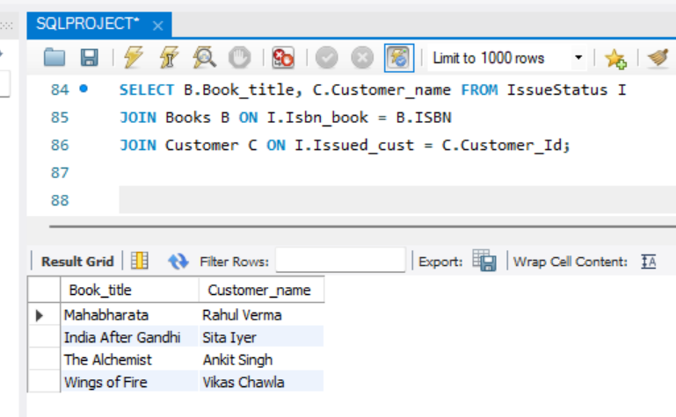

1. ***Display the total count of books in each category.***

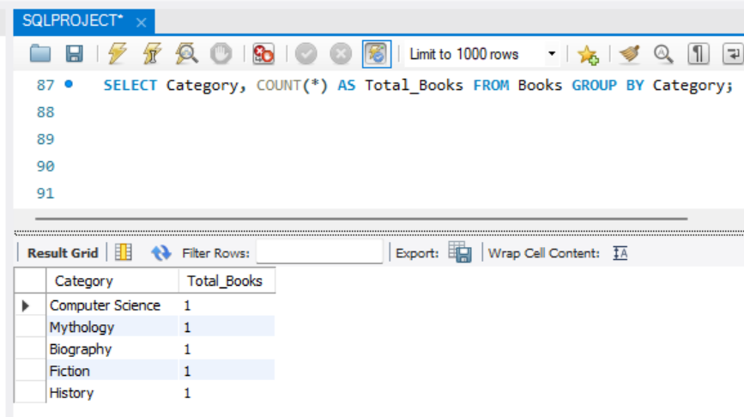

1. ***Retrieve the employee names and their positions for the employees whose salaries are above Rs. 50,000.***

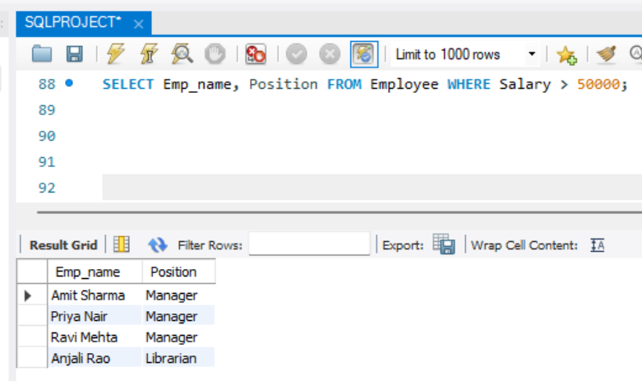

1. ***List the customer names who registered before 2022-01-01 and have not issued any books yet.***

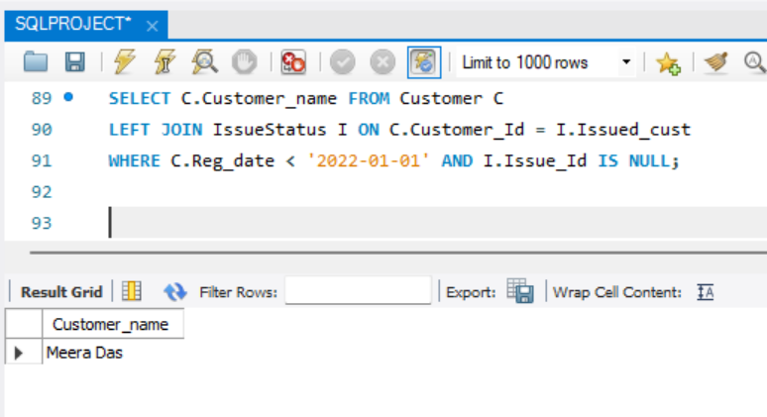

1. ***Display the branch numbers and the total count of employees in each branch.***

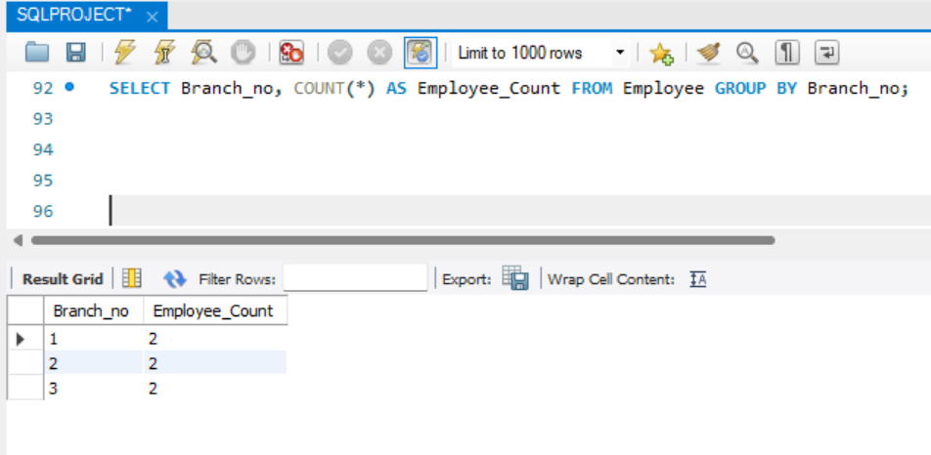

1. ***Display the names of customers who have issued books in the month of June 2023.***

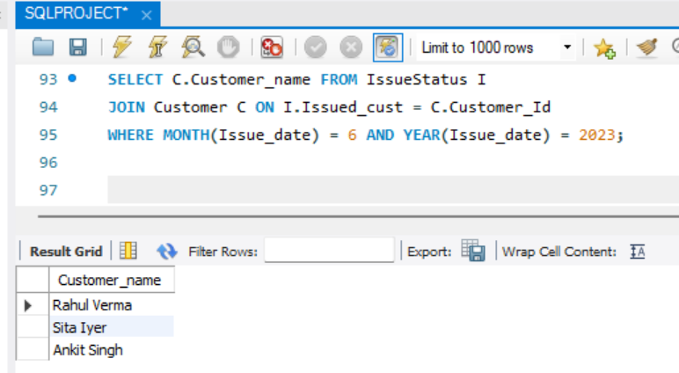

1. ***Retrieve book titles from the books table containing the word 'history'.***

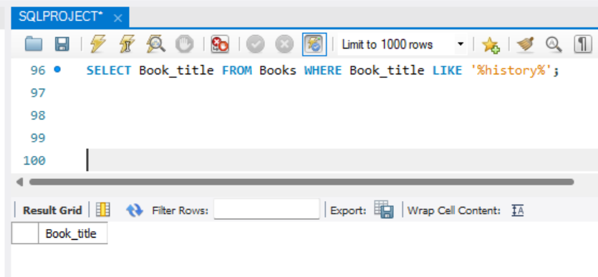

1. ***Retrieve the branch numbers along with the count of employees for branches having more than 5 employees.***

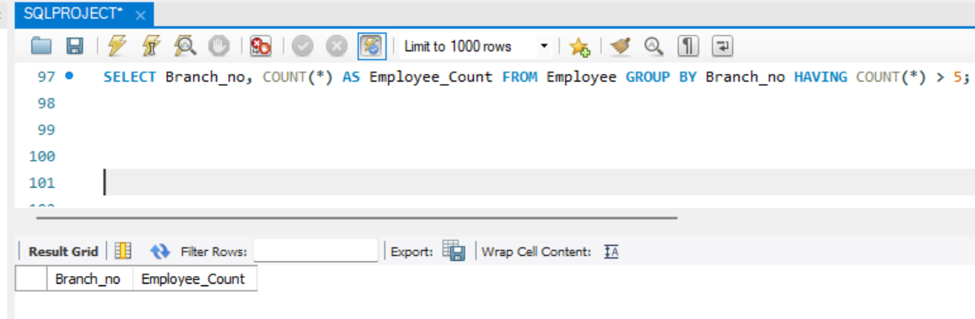

1. ***Retrieve the names of employees who manage branches and their respective branch addresses***

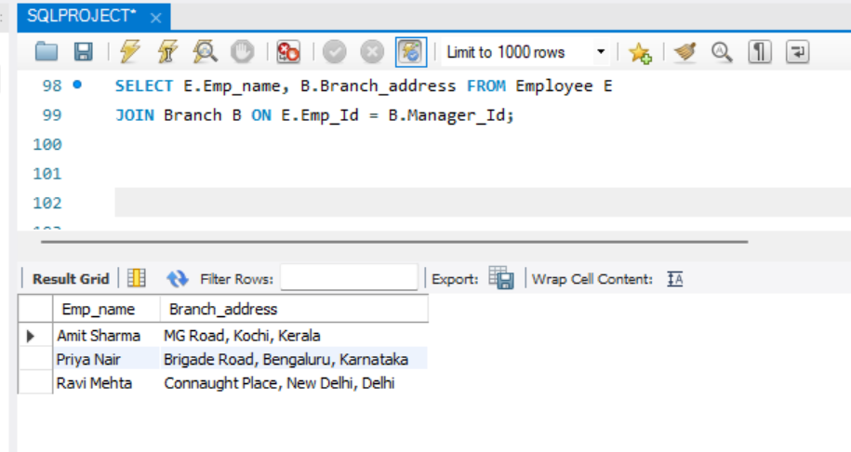

1. ***Display the names of customers who have issued books with a rental price higher than Rs. 25.***

